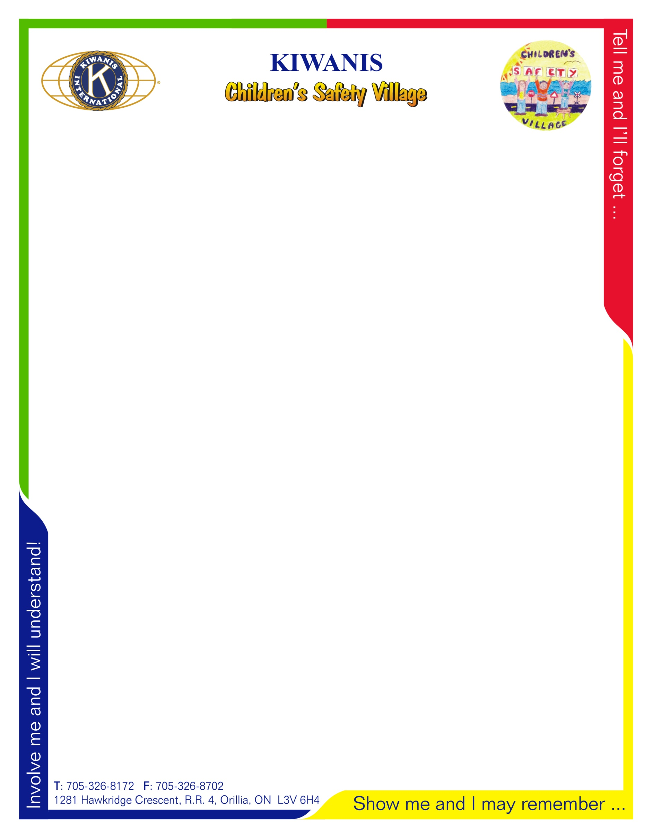

**Kiwanis Children’s Safety Village**

**Lesson Plan Overview**

***Ontario Provincial Police***

Grade 1 – Elmer the Safety Elephant Traffic Safety

* Keep away from parked cars
* Look both wats before crossing the street
* Play in a safe place
* Walk when you cross the street
* Bullies never win

Grade 2 – Bert and Gert video

* Stranger danger
* How to be safe at home when alone
* Never let a stranger into your house or let them know you are alone
* You don’t have to bullied prevention and tips

Grade 3 – Jr. Constable Program

* How to be a better person and role model in your community
* Jr. Constable Promise and badge ceremony

Grade 4 – Internet Safety video and tip sheet for parents

* How to stay safe while using your computer
* Not giving out personal information
* Problems associated with web cams

Grade 8 – Drug class/youth and the law/ sexting